|  |  |  |  |
| --- | --- | --- | --- |
| **CS102** | **Spring 2023/24** | Project Group | 3I |
| Instructor: | **Uğur Güdükbay** |
| Assistant: | **Melih Coşğun** |

|  |  |  |
| --- | --- | --- |
| **Criteria** | **TA/Grader** | **Instructor** |
| Presentation |  |  |
|  |  |  |
|  |  |  |
|  |  |  |
|  |  |  |
| Overall |  |  |

University Sync

Prototype

**Arda Ege Erdoğan, Atilla Akkuş, Berkay Demirçin, Muhammad Musa Qureshi, Zaeem Masood Sheikh**

|  |
| --- |
| **Report Type**  **Detailed Design Report**  **27 April 2024** |

# Introduction

Our campus wide social platform is designed with user experience as a priority. As a design philosophy, our application’s design ensures that users can access all features of our app in a simple, intuitive yet modern way. Our app, UniversitySync, works on a segmented UI design where distinct features are divided into their own tabs. After going through the sign in/sign up process, users will be greeted by a home screen featuring six buttons at the top of the screen: “Home”, “Food”, “Dormitories”, “Social”, “Forum”, and another tab containing the users name and last name which will be referred as the “User Thumbnail” in other sections. These six buttons are the main navigational tool of the app and they will stay on top, on all other tabs. Despite all this, the app is designed in a way that minimizes the required clicks to get to a desired page, and ensures the user is always only a few clicks away from any page. To design the app, we used Figma [1], and we utilized Octopus [2] to implement the sitemap below.

# Details

## Sign In/Sign Up Page

When the user first opens the program, they will be prompted to login with the screen (shown below). After filling out the text fields and **clicking “Sign in”**, the user will get taken to the home page if the entered strings correspond to a user, else they will be prompted to either register by **clicking the “Register” button**.

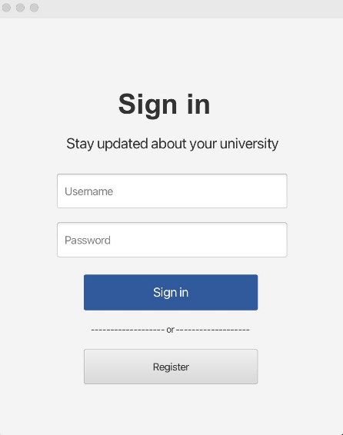

After clicking the “Register" button in the Sign in page, users will be taken to the register page pictured below. After **clicking “Register”**, if the information is unique and valid, a new account will be created. If the information is that of an existing account, the “Already Registered” message will be displayed as can be seen in the bottom of the below image. In addition, the register page features a dropdown menu of majors and dormitories that the user can choose from.

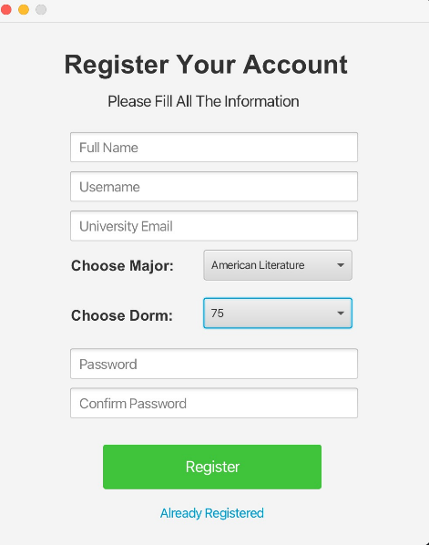

## Navigation Bar and Home Page



The above bar is the main navigational tool of our app. This bar and its associated buttons Home, Food, Dormitories, Social, Forum and User Snapshot will stay consistent on all pages in the application. **The “Home” button will take the user to the home page (pictured below)**, while food, dormitories, Social, Forum and User Snapshot buttons will take the user to their associated pages, whose details will be discussed in detail later under their own respective titles.

Users will be taken to this page after they **press the “Sign in” button featured in 2.1**. The navigation bar includes a **“Home” button that brings the user back to this page** (again, the top 6 buttons stay consistent throughout all pages). The home page will feature a **search bar that allows the users to search for other users** to connect with.

In addition, the home page will display some recent forum posts which the user can refresh by clicking on the “Refresh” button shown. **Clicking on the username** (shown as @anonymous6322) in the image **will take the user to the poster’s profile.** Buttons displayed at the bottom of the post, **“Like” button will increment the like count of the post (or decrement in the case of de-selecting)** and **add the post to the users “Liked” list** (will be discussed further in 2.7). The **“Message” button will allow the user to send the poster a direct message**. **“Comment” button will take the user to the expanded look of the forum post** and **“Add Friend” will send the poster a friend request.** Buttons shown below inside the red circle, **the “trash can” button will delete the post, while the “pencil” button allows the poster to edit the post**. Note that “Message”, “Add Friend” buttons will be disabled for the original poster, while “trash can”, “pencil” buttons would be **disabled** for anyone other than the original poster. Note that trying to delete a post would send a confirmation prompt (pictured below, right)

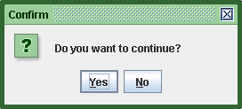

Another feature the home page houses is the “Events” tab, which shows upcoming events. Users can **click the “Follow” button pictured below to follow an event** (and Unfollow to unfollow if they are already following it). Following an event will send the user a desktop notification (system notification, pictured below, right) some time before it starts.

**Clicking on the “Add” button in the events tab will bring the below page where users can add their events**. Users can set the date and time to their desired time, fill out the text fields and **click “Add +”** to post their event.

## Food Page

**Users can navigate to this page by clicking the “Food” button** (highlighted red), this page houses a list of cafeterias and information about them. This page will contain a list of all the cafeterias, their ratings, and a price range. The **user can click on the names to go to a cafeteria’s individual page**.

Note that the **list of cafeterias can be filtered through and sorted via the “Filter” button** (expanded form displayed below), when **search or remove filter is clicked this expanded frame will be closed**.

The individual page of a cafeteria, accessed by **clicking on a cafeteria’s name** in the Food page, (In this case Bilka from the above image) is pictured below.

The **red button at the top left will take the user back to the Food page**. Note that the “Menu” would continue down if enough entries are entered. **The user can click on “Click to see more reviews” to access the review page of a specific cafeteria**. Clicking it brings up the review page pictured below.

Similarly, the **red button takes you back to the cafeteria’s information page**, this page features multiple text fields, **after the user fills the text fields with the relevant info they can click “Submit Review” to submit their review**. **Clicking on the trash can button will delete the review**, but it will be **disabled** for anyone other than the original poster, it will also send out a prompt to confirm the deletion (pictured below).



## Dormitories Page

**Clicking on the dormitories button (highlighted red) will reveal a dropdown menu with 2 options, “Dormitory Info” and “Dormitory Postings”**, pictured below.

**Clicking on “Dormitory Info” will bring the user to the dormitory list page that contains a list of dormitories**, akin to the “Food” page (pictured below).

The user can **filter and sort these dormitories by clicking the “Filter” button** (pictured below). Clicking on “Remove filter” or “Search” will terminate the filter frame.

**Clicking on any dormitory’s name will take the user to it’s associated information page**. Pictured below, this page includes a relevant image of the dormitory along with a description. The **red button will take the user back to the dormitory list** page. Again, users can click “Click to see more reviews” to go to the dormitory’s unique review page.

**After “Click to see more reviews” is clicked, the below page is opened**.

Clicking the **red button will take the user back to the “Dormitory Info” page**. After filling the text fields “Rate out of 5” and “Write your review”, the user can **submit their review by clicking the “Submit Review” button**. Note that the trash can button works the same way as previous examples, it deletes the review and is only clickable by the original poster, and it prompts the user to confirm the deletion after being clicked.

In addition to the “Dormitory Info” option, the user can also **click on the “Dormitory Postings” in the dropdown menu to navigate to the dormitory postings page (pictured below)**.

The user can **filter and sort these dormitory posts by clicking the “Filter” button** (pictured below). Clicking on “Remove filter” or “Search” will terminate the filter frame.

**Users can also make new posts by clicking the “Make a post” button,** located next to the filter button. Clicking this button will take the user to a different page (pictured above) where they will see a text informing them that their dormitory information will automatically be entered. After filling out the text field and **clicking the “POST” button**, users will be taken back to the postings page and their post will be displayed.

Users can **click on a posting** (blue rectangle containing the image, located above) **to see it’s expanded form with more info**.

The **red button will take the user back to the dorm postings**, the **“Message” button will message** the poster and the **“Transfer” button will send out a transform request** to the poster.

## Social Page

The “Social” page will be accessed by clicking the “Social” button (highlighted red). This page consists of 4 individual subpages. My Friends, All Messages, Events, Friend Requests.

Firstly, the “My Friends” page pictured above houses all friends of the user and is the default page that comes up when the Social page is opened. The **user can click on each user to go to their profile page**. The search bar will search through the users current friends. **Clicking the “Message” and “Unfriend” buttons messages the person and unfriends them respectively**. **“Add New Friends +” button brings up a search bar to search through all users** (pictured in the “Friend Requests” page, same function).

**Clicking the “All Messages” button brings the user to the messaging page**. In this page, the user can click on names of other users to bring up the chatting tab where they can send 1-1 messages. After the user types their message in the text field with prompt “Type your message…” they can **click the arrow icon button to send their message**. The user can also choose to view read, unread or all messages **by clicking their respective buttons**.

**Clicking on the “Events” button brings up a page where the user can view the events they’re following**. **Clicking on the pencil button next to the name of the event allows the original poster to edit information regarding the event**. This button will be **disabled** for everyone other than the original poster.

**Clicking on the “Friend Requests” button brings up the pending friend requests**. Clicking **“Accept +”** will add the user as a friend, while clicking **“Reject”** rejects the friend requests and discards the request. The **“Add New Friends” button works the same way as before, displaying a search bar to search through users to send out a friend request** (pictured below). **Clicking “Search” searches for a user with the username in the text field**.

## Forum Page

Clicking the “Forum” button from the navigation bar (highlighted red) will bring the user to the Forum page displayed below.

**Clicking on the username** (shown as @anonymous6322) in the image **will take the user to the poster’s profile.** Buttons displayed at the bottom of the post, **“Like” button will increment the like count of the post (or decrement in the case of de-selecting)** and **add the post to the users “Liked” list** (will be discussed further in 2.7). The **“Message” button will allow the user to send the poster a direct message**. **“Comment” button will take the user to the expanded look of the forum post** and **“Add Friend” will send the poster a friend request.** Buttons shown on the top right of the post (blue rectangle), **the “trash can” button will delete the post, while the “pencil” button allows the poster to edit the post**. Note that “Message”, “Add Friend” buttons will be disabled for the original poster, while “trash can”, “pencil” buttons would be **disabled** for anyone other than the original poster. Note that trying to delete a post would send a confirmation prompt (pictured below).



Clicking the “Filter” button will bring up the filtering frame where users can type their desired tags and filter their friends posts and the entered tags.

**Clicking on the “Make a post” button** will bring the user to the post creation page pictured below. The users will have an option to attach images (pictured below, system file chooser) and add tags to the post. Note that these tags are for when the user is filtering forum posts. After filling out the relevant information, **clicking the “POST” button will post the post**.

In addition, users can **click on the post (blue rectangle border included)** to see an expanded view of the post. **Clicking red arrow** will take the user back to the forums page, users can click “See Attached Files” to view attached images of the post. The numbers at the top right of each individual comment is the comments number**. Clicking the trash can and pencil icons have the same functionality and behavior as before**, they are used to delete and edit posts respectively and are only active for the original poster.

* 1. **Profile Page**

**Clicking on the User button (highlighted red) will reveal a dropdown menu with 3 options, “Profile”, “Liked”, “Logout”** pictured below.

**Clicking on the “Logout” button will log the user out of the application** and bring them back to the login page where they will need to sign in again.

**Clicking on the “Liked” button** **will show all the posts user has liked**, as shown below.

**Clicking on the “Profile” button brings up the user’s profile** (shown below). The profile includes some information about the user, including the profile picture. When the user is viewing their own profile they will see the below image. The “My Posts” subpage shows the posts made by the user, the buttons’ functionality is the same as it was described in 2.2 and 2.6.

**When the user clicks the “Edit Profile**”, they are brought to the profile editing page. This page includes the same information as the previous page regarding user info, however the user can also fill out the text fields to change their password, update their biography and more. After they enter the relevant information into the text fields, they can click “Submit Changes” to update their information.

The **“Contact Us” button, after clicking on it, takes the user to a page where they can contact administrators by submitting a form**, pictured below. Users can fill out their desired suggestions, complaints in the given text field and **click the “Submit Message” button to send their feedback** to administration.

If the profile being viewed is not the user’s own, accessed by clicking on a user’s name in forums etc. or by searching, the UI will be different. Instead of seeing their posts, they will only see general information about the user such as name, department, bio. In addition they will have the option to **message the other user by clicking the “Message” button** below or **Friend/Unfriend the other user by clicking on the “Unfriend” button** (Would change to Friend in the case the two users are not friends).

# Summary & Conclusions

Our app is going to utilize modern technologies such as JavaFX to implement a user friendly, intuitive, and modern UI. Overall, the primary aim of the UI is to provide the user with as much information as they need, while keeping readability and aesthetics in mind. UniversitySync aims to be a highly ambitious program with extensive UI design.

# References

1. Adobe. (n.d.). *Figma*. Retrieved from https://www.figma.com/ Last visited: 05.04.2024

2. SIA Scada. (n.d.). *Octopus*. Retrieved from https://octopus.do/ Last visited: 05.04.2024